Refugee crisis in Europe
September 04 2015
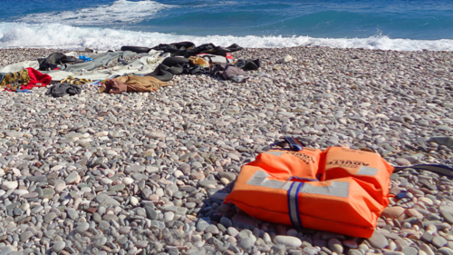
As the biggest refugee crisis in recent times grips Europe, CAFOD and our supporters are calling on the Prime Minister to do more to support vulnerable Syrian refugees resettling in the UK as quickly as possible.
Make your voice heard, email the Prime Minister
A third of the refugees making the harrowing journey to Europe have fled the conflict in Syria, where a staggering 12.2 million people have been forced to leave their homes since the conflict started on 15 March 2011. At least four million of these people have fled the country.
CAFOD’s Director of Advocacy Neil Thorns said, “While there is no end in sight to the conflict in Syria, people will take desperate action to cross land and sea, risking their lives and those of their children to reach a place of safety.
“We and our Catholic supporters across England and Wales call on David Cameron to ensure the UK resettles its fair share of vulnerable refugees as quickly as possible. While the humanitarian aid the UK has provided has been commendable, we must do more.
“Our faith calls us to care for our vulnerable brothers and sisters, and we believe that Great Britain has a moral responsibility to play its part and continue our honourable tradition of providing sanctuary for those in need of protection.”
CAFOD has also set up an appeal for donations to support our Caritas partners across Europe who are working directly with vulnerable refugees.
Donate here to the refugee crisis appeal
Our sister agencies in the Caritas network across Europe are playing a significant role in providing support to tired and traumatised refugees. Evelina Manola, a social worker with Caritas Greece, which is supporting vulnerable refugees on the islands of Kos and Chios, told us that around eight out of ten of the refugees arriving on the islands are Syrian:
“They pay $1200 to the traffickers and arrive on plastic dinghies from Turkey. The kind of thing you might buy for your holiday, they are really unsafe. There is a great need, people are living in inhumane conditions, sleeping outside without clean water and adequate food.
“We are doing all we can to help, it might be a drop in the ocean, but it is still a drop.”
Make your voice heard, email David Cameron

