Our Lady of Mount Carmel Redditch
CAFOD/Laudato Si Group
We are a small, friendly group who undertake a range of activities to support the mission and aims of CAFOD within the Parish. We are committed to the integrity of creation and justice and peace for all. We see the work of CAFOD as an important way to live out our faith and the social teachings of the Church.
We particularly feel that raising awareness and campaigning are important as both can lead to positive change. Our faith calls us to address injustice in the world and CAFOD’s campaigns enables us to put our faith into action – it is a very effective way of loving our neighbour. We are currently supporting CAFOD’s Fix the Food System campaign as well as an ongoing commitment to combatting climate change.
We started in 2005 inspired by the Make Poverty History campaign when three coach loads of parishioners went to the rally in Edinburgh. Since then our actions have included: a rich world poor world supper; numerous campaign petition and card signings, creation walk; Livesimply picnic and a showing of The Letter film. We also host an annual ecumenical service for the Season of Creation.
Addressing the climate crisis is a major priority. We merged with the informal Climate Change group which arose out of a creation celebration Mass in September 2019 to form the parish CAFOD/Laudato Si Group.
There is only so much you can do but in summary we try to priortise the following:
- Supporting CAFOD’s campaigns including political lobbying
- Promoting Laudato Si through parish climate project
- Promoting Fair Trade (although unfortunately we are not a Fair Trade Parish)
- Supporting CAFOD Fast Days.
- Joint working with parish schools (we have four)
Our latest campaign action was a parish signing of Salina’s letter when 240 signatures were obtained at weekend masses throughout August.
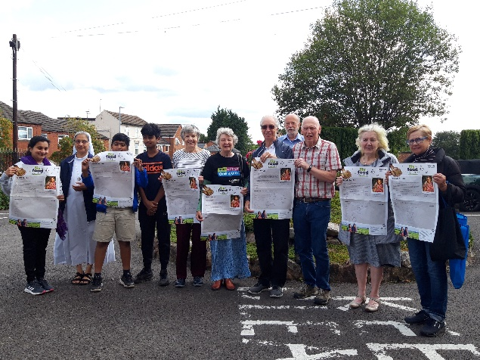
We meet on an occasional basis and new faces are always welcome. For more information, please speak to Susan Salam; Bob and Jo Mansell or Jim Quinn here at the assembly. Or email us at: laudatesiolmc@proton.me

